Financial Econometrics CW – Pre-report cheatsheet
Nov 10, 2026 · @Nakul Pillai

Headline results
Expanding-window LASSO beats the random walk, but modestly, and nearly all of the absolute gain comes from three months in spring 2020.
This sheet holds, in report order, every chart and table the notebook produces, what each one says, and the small decisions behind it. Tags match the Decision Log: DECIDED, PROPOSED, OPEN. Economic readings are our interpretation of the signs and are not tested causally; the report should say "consistent with", not "proves".
- Accuracy. Out-of-sample R² against the random walk is 9.0% (RMSE 2.336 vs 2.449 percentage points), and the direction of the change is right in 60.2% of months. Test sample: 113 forecast origins, Jan 2015 to May 2024.
- Not just an artefact of 2020. LASSO still beats the random walk when March to May 2020 are left out: 5.7% if only those months are dropped from the scoring, 10.1% if the model is re-run without them. But those three months are 90% of the random walk's total squared error and 94% of LASSO's cumulative squared-error gain, so the headline RMSE is set by them.
- What the model relies on. The spread level (mean reversion) is kept at every origin with a negative sign, and gasoline is the next most stable. The other predictors only appear once 2020 is in the training data.
- Diagnostics. Every test except VIF flags a problem: errors are autocorrelated, their variance changes, and the relationship breaks around 2005, 2015 and 2020. The out-of-sample evaluation does not rely on OLS standard errors, so the forecast comparison still stands.
- Trading. Trading the sign of the forecast made $16.05 per barrel of spread over the test period ($8.52 without March to May 2020), Sharpe 0.74 (0.52). Always being long the spread lost $1.65.
- Rolling window is worse. Rolling LASSO scores 6.3% and rolling OLS −20.4%. The rolling LASSO keeps no predictors at all at the end of the sample.

1. The project in brief
We forecast next month's change in the oil calendar spread, so a spread trader knows whether the front of the futures curve is likely to steepen or flatten.
The reader is a trader who is not an econometrician, so every choice needs a plain-words reason. The brief grades clarity, diagnostics and interpretation, not beating the market, so honest reporting of weak results is part of the job.
Decision | What we chose | Why | Status
Target | (CL2 − CL1) / CL1, forecast as next month's change, spread(t+1) − spread(t); level form reported alongside | It is what a calendar-spread trader holds, it is a ratio so it compares across years with very different prices, and the brief lists it as valid | DECIDED
Level vs change | Lead with the change | With plain OLS the two give identical forecast errors if today's spread is a predictor. LASSO's penalty breaks that, and the change form shrinks toward the random walk | DECIDED
Frequency | Monthly: 355 rows (Dec 1994 to Jun 2024), 352 usable forecast origins (Feb 1995 to May 2024) | The dataset supplies every candidate monthly, so nothing is converted or filled in; it suits a medium-horizon spread view. Cost: fewer observations and slower reaction than daily data | DECIDED
Horizon | One month ahead only | 2 and 3 months ahead were discussed as a possible later extension (separate model per horizon); parked | DECIDED
Model | LASSO on all candidates, with an OLS comparator on the same variables | LASSO selects among many overlapping predictors; the brief allows one or two models | LASSO DECIDED, OLS comparator PROPOSED
Benchmark | Random walk: forecast change = 0 | The brief requires at least one naive benchmark | DECIDED
Split | Train 1995 to 2014 (239 months); test Jan 2015 to May 2024 (113 origins) | Same test period whichever window type is used | DECIDED
Window | Expanding is the main case; rolling (120 months) as comparison | Both run on the same 113 months; rule agreed beforehand is lowest RMSE, which picks expanding (2.336 vs 2.371) | OPEN
Software | Python in a Jupyter notebook | Code, charts and commentary sit together | DECIDED
For the report (introduction): we forecast the one-month-ahead change in the WTI calendar spread with LASSO and test it out of sample against a random walk, because the spread is the quantity a calendar-spread trader holds and a forecast of it maps straight onto a trade.

2. Data and predictors
We use only the three monthly sheets of Oil Data.xlsx: 16 candidate series plus today's spread, 17 features in all.
- Sheets used (DECIDED). Industry_M (CL1, CL2 and the industry series), Macro_M and StockPrices_M. The daily and weekly sheets are not used, so no frequency conversion is needed.
- Join. On year and month, because the sheets are sorted newest first and only the macro sheet uses calendar month-ends (the others use the last trading day). Monthly CL1 and CL2 equal the last daily price of the month exactly (checked).
- Removed series. Individual oil-company stocks (ExxonMobil, ConocoPhillips, Chevron, BP, Shell, TotalEnergies): they repeat the oil and gas index and Shell is missing 127 months (DECIDED). Total Open Interest: it is exactly Commercial Long plus Commercial Short (PROPOSED). Brent: the professor flagged an issue with the Brent data (DECIDED).
- Timing rule (avoids look-ahead). Each row is a forecast origin, the end of month t. It uses only information available then, and its target is the change from t to t+1. CPI and industrial production get one extra month of lag for publication delay. That extra lag comes from a teammate's playbook and is unverified; the industrial production series is probably final-vintage data, which the report should admit.
- Transformations. Percentage changes (log differences) for prices and quantities that trend, plain differences for rates, VIX and CPI, and the series as it is for the dollar-index return and the spread level. Step 4 of the notebook tests whether this worked (see section 4 here).
Predictor | Transformation | Extra lag (months) | Economic link
Spread level (today) | level | 0 | Contango and backwardation are bounded by storage and financing costs, so a wide spread tends to close: mean reversion
3-2-1 crack spread | log diff | 0 | Refining margin; strong margins mean strong demand for crude
Baltic Dry Index | log diff | 0 | Shipping cost, a proxy for global demand
Daily production | log diff | 0 | Supply
Inventories | log diff | 0 | Storage: high stocks favour contango, low stocks backwardation
Rig count | log diff | 0 | Drilling activity, a leading indicator of future supply
Commercial long / short | log diff | 0 | Hedgers' positioning in the futures market
CPI (year on year) | diff | 1 | Inflation and macro conditions
3-month yield | diff | 0 | Cost of financing stored oil (cost of carry)
10-year yield | diff | 0 | Longer-term rates and growth expectations
Industrial production | log diff | 1 | Real activity, a GDP proxy for oil demand
S&P 500 | log diff | 0 | Risk appetite and growth
Dollar index return | level | 0 | Oil is priced in dollars; a stronger dollar tends to weigh on prices
VIX | diff | 0 | Market stress
Gasoline price | log diff | 0 | End-product price, a read on prompt demand
Dow Jones US Oil & Gas Index | log diff | 0 | The equity market's view of the oil sector
The economic-link column is our own reasoning and is not sourced; check it against lecture or industry references before the report cites it.
Figure 2.1: correlation of each predictor with next month's spread change (training years only). Only two predictors have a correlation above 0.15 in size: today's spread (−0.31) and gasoline (−0.18). Commercial long (−0.13), Baltic Dry (−0.11), CPI (−0.11) and commercial short (−0.10) are next, and industrial production (+0.10) and rig count (+0.09) are the largest positive ones. Everything else is close to zero, so we should expect weak predictive power. It uses training years only, so the test sample is not peeked at.
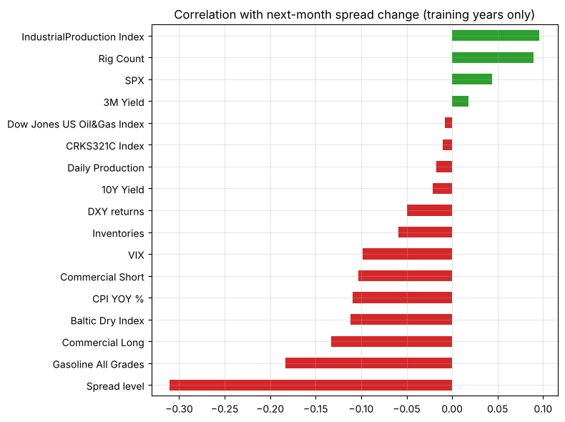
For the report (data and predictors): we use the monthly sheets, remove the individual company stocks, Total Open Interest and Brent, transform each series to remove trends, and lag the publication-delayed series by an extra month so the forecast only uses information a trader would have.

3. A first look at the target
The spread normally sits within a few percent either side of zero and pulls back toward it, but it has three spikes: late 2008 (about 11%), 2015 to 2016 (about 5%) and March to April 2020 (19.7% and 16.0%).
Figure 3.1: the spread level (top) and the next-month change we forecast (bottom). The grey band is March to May 2020. The change series is noisy and centred on zero, which is why a random walk is a hard benchmark to beat. The 2020 spike produces the two largest changes in the sample: +19 points going in and −15 coming out.
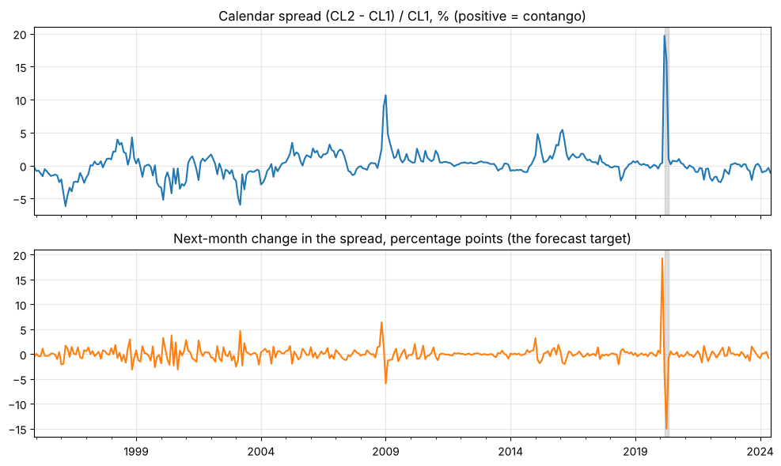
Table 3.2: has the spread changed character over time? A first look at all the data before any modelling. The "mean reversion slope" regresses next month's change on today's spread: a negative number means a high spread tends to fall back.
Period | Months | Mean spread % | Std of spread % | Mean-reversion slope
1995–2004 | 120 | −0.85 | 1.90 | −0.26
2005–2014 | 120 | +0.90 | 1.61 | −0.22
2015–2024 | 113 | +0.59 | 2.72 | −0.41
The average flips from backwardation (−0.85%) to contango (+0.90%) between the first and second decade, and the pull-back is strongest in the last one (−0.41, so about 40% of a gap closes the next month, though 2020 is part of that). Over the full sample the mean is 0.20%, the standard deviation 2.24% and the lag-1 autocorrelation of the spread 0.71. This is the case for testing a rolling window, and the 2005 Chow break date comes from here (it is data-informed, so say so).
Table 3.3: the COVID months. This is the evidence behind the robustness check in section 7.
Month end | CL1 ($) | CL2 ($) | Spread %
Jan 2020 | 51.56 | 51.68 | 0.23
Feb 2020 | 44.76 | 44.94 | 0.40
Mar 2020 | 20.48 | 24.51 | 19.68
Apr 2020 | 18.84 | 21.85 | 15.98
May 2020 | 35.49 | 35.84 | 0.99
Jun 2020 | 39.27 | 39.34 | 0.18
Jul 2020 | 40.27 | 40.57 | 0.75
Aug 2020 | 42.61 | 42.90 | 0.68
The dislocation sits in March and April, and May is the snap-back. Dates behind it: OPEC+ talks collapsed on 6 March, the WHO declared a pandemic on 11 March, and front-month WTI traded below zero on 20 April 2020. The window of March to May comes from these events and the spread's own spike, not from the model results. The sources are listed in the Decision Log.

4. Stationarity
Eleven of the raw predictors have a unit root, and after our transformations every series is stationary except two that the tests cannot agree on; this is what justifies the transformations.
What the tests say. ADF has the null that the series has a unit root (a stochastic trend). KPSS has the reverse null: that it is stationary. Both agreeing means we are confident; disagreeing is flagged "unclear". It matters because regressing one trending series on another can give a high R² even when they are unrelated (a spurious regression). Stationarity is what we want in the target and the predictors.
Series | Raw | After transformation
Target: change in spread | n/a | stationary (ADF p 0.000, KPSS p 0.10)
3-2-1 crack spread | unit root | stationary
Baltic Dry Index | unclear | stationary
Daily production | unclear | unclear (KPSS p 0.014)
Inventories | unit root | stationary
Rig count | unit root | stationary
Commercial long / short | unit root | stationary
CPI | stationary | stationary
3-month yield | unit root | stationary
10-year yield | unit root | stationary
Industrial production | unit root | stationary
S&P 500 | unit root | stationary
Dollar index return | already a return | stationary
VIX | stationary | stationary
Gasoline | unit root | stationary
Dow Jones US Oil & Gas | unit root | stationary
Spread level | unclear (ADF p 0.000, KPSS p 0.036) | unclear (same series, KPSS p 0.037)
Reading the exceptions.
- Spread level. It is very persistent (lag-1 autocorrelation 0.71), ADF rejects a unit root and KPSS only just rejects stationarity. We keep it in levels because it is the mean-reversion predictor, and the target we forecast is its change, which is clearly stationary.
- Daily production. Its values move in steps, so the tests disagree even after differencing. It is never selected by LASSO, so this does not affect any result.
- CPI and VIX were already stationary but are still differenced, for consistent treatment (a judgement call; say so if asked).
For the report (stationarity): we tested the target and every predictor with ADF and KPSS. Differencing does not guarantee stationarity, so we checked that it worked: the target is stationary, and every transformed predictor is except two, which we flag.

5. Model and forecasting design
Every month from Jan 2015 to May 2024 we refit LASSO on the data available then, forecast next month's change in the spread, and compare it with a forecast of no change.
The forecasting loop. For each of the 113 origins: take the data available (expanding: every earlier row; rolling: the latest 120 months), fit LASSO and OLS, forecast the change from that month to the next, and store the forecast, the actual change, the penalty and which predictors LASSO kept. A row at origin t is only used for training from origin t+1, because its target is only known then (this avoids look-ahead).
Choice | What we do | Why | Status
Standardising | Each predictor scaled to mean 0, variance 1, using the current window only | LASSO's penalty is not scale invariant; using only the window keeps the test months out | DECIDED
Penalty (lambda) | Chosen by time-series cross-validation inside each window: 5 time-ordered folds, 60 candidate penalties from 0.0000001 to 0.1, take the one with the lowest cross-validation error | Ordinary K-fold would let the model learn from the future; the final test months never influence the penalty | method DECIDED; 5 folds and the lowest-error rule are placeholders (OPEN)
Expanding window | All data from Feb 1995 up to the forecast date (239 months at the first forecast, 351 at the last) | More data, steadier estimates; old regimes keep their weight | main case, OPEN
Rolling window | Latest 120 months only (the first window is 2005 to 2014) | Adapts faster if the market changed; fewer observations, noisier selection | comparison, OPEN
OLS comparator | Plain regression on the same 17 variables and windows | Easy to explain, shows what LASSO's shrinkage adds | PROPOSED
Benchmark | Random walk: forecast change = 0, so the best guess for the level is today's spread | Spread changes are treated as unpredictable noise unless the model proves otherwise | DECIDED
Level form | Forecast level = today's spread + forecast change | Reported alongside the change | DECIDED
Metrics (DECIDED: use all of them and keep what proves useful).
Metric | What it measures | Note
RMSE | Typical size of the miss, in percentage points; big misses count most | Square root of the MSE in the lectures, so it is in the target's units
MAE | Average absolute miss | Less driven by a few huge months; in the lectures (ARMA)
MAPE | Average miss as a percentage of the actual change | May be dropped: the actual change is often near zero (18 of the 113 test months move by less than 0.1 points), and the random walk scores exactly 100% by construction
Out-of-sample R² | 1 minus the model's squared error over the random walk's: positive means better than the benchmark | The headline measure
Hit rate | Share of months where the forecast has the right sign | The measure closest to trading profit (lecture: sign accuracy)
The Diebold-Mariano significance test was dropped because it is not in the lectures; we stick to what is taught. That means there is no formal test that the improvement is statistically real, and the report should say so.
Window choice rule. Placeholder rule, to be agreed by the team before results are quoted: pick the window with the lowest LASSO RMSE. The notebook applies it and picks expanding (2.336 vs 2.371 percentage points).
After LASSO is fitted (DECIDED): we assess which predictors it kept, their signs and sizes, and whether they stay chosen over time; see section 8.
For the report (methodology): we estimate a LASSO on 17 standardised monthly predictors, re-estimated every month on past data only, with the penalty set by time-ordered cross-validation inside each window, and compare its one-month-ahead forecasts with a random walk using RMSE, MAE, out-of-sample R² and hit rate.

6. Out-of-sample results
Expanding-window LASSO is the best model on every measure, with an out-of-sample R² of 9.0% against the random walk; the rolling versions are worse.
Table 6.1: all 113 test origins (Jan 2015 to May 2024). Errors are in percentage points of spread. MAPE is left out here (see section 5).
Window | Model | RMSE | MAE | Out-of-sample R² | Hit rate
both | Random walk | 2.449 | 0.865 | 0 | n/a
Expanding | OLS (all 17) | 2.364 | 0.945 | 6.8% | 60.2%
Expanding | LASSO | 2.336 | 0.818 | 9.0% | 60.2%
Rolling (120 months) | OLS (all 17) | 2.687 | 1.173 | −20.4% | 54.9%
Rolling (120 months) | LASSO | 2.371 | 0.904 | 6.3% | 46.9%
What it says.
- Expanding LASSO has an RMSE 4.6% below the random walk and a lower MAE, so it beats the benchmark on both the big misses and the typical one.
- Expanding OLS beats the random walk on RMSE but not on MAE (0.945 vs 0.865): it does better in the extreme months and worse in ordinary ones. This is the case for LASSO's shrinkage over using every predictor.
- Rolling is worse for both models. With only 120 months, 17 predictors are too many for OLS (−20.4%), and rolling LASSO has a hit rate of 46.9%, below a coin flip. More data helps here, which supports expanding as the main case.
- Hit rate caution. 60.2% over 113 months is about two standard errors above 50%, so it is suggestive and not conclusive, and we have not tested it formally.
Figure 6.2: where the gain over the random walk came from (expanding window). It plots the running total of the random walk's squared error minus the model's, so a rising line means the model is ahead. Between 2015 and 2019 both lines barely leave zero. In March to May 2020 LASSO jumps from 0.0006 to 0.0063 and then stays flat. OLS first falls to −0.003, then jumps to 0.0075, and decays to 0.0046 by 2024. Of LASSO's total gain of 0.0061, 0.0057 (94%) comes from those three months; OLS gains 0.0067 there and gives back 0.0021 elsewhere. LASSO's forecasts then had the right sign but were small: for the April 2020 origin it forecast −1.7 points against an actual −15.0. The report should say the gain over the random walk in squared error is concentrated in a shock month where the model was directionally right.
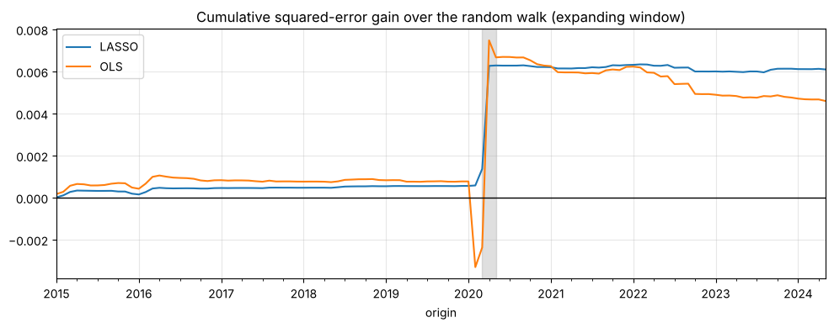
Figure 6.3: forecast versus actual spread level (expanding window). The LASSO forecast level is almost on top of the random-walk level, and both trail the actual by about a month at the 2016 and 2020 peaks. The model is "today's spread with a small pull toward normal", so it cannot anticipate spikes; it trims the error slightly. For a trader, this is a model of gentle mean reversion, not a turning-point predictor.
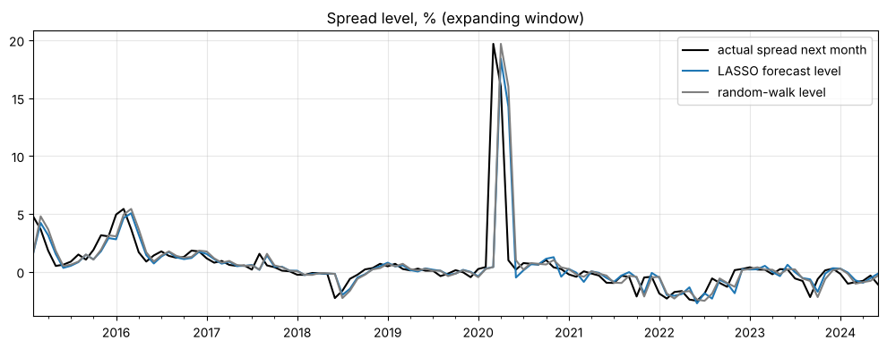
For the report (results): expanding LASSO beats the random walk out of sample (R² 9.0%, RMSE 2.34 vs 2.45), rolling windows do worse, and the gain is concentrated in March to May 2020, so the evidence for forecasting ability is modest.

7. Robustness: the without-COVID re-run
LASSO does as well or better in a world without the 2020 shock (R² about 10% when the model is re-run without it), so the result is not an artefact of 2020; training on 2020 actually hurts ordinary months.
What we did (DECIDED). Exclude by the month being forecast (the target month). Two versions: March to May 2020 removed, then all of 2020 removed as a wider check. Two ways of excluding:
- Scoring only. The model is unchanged and the excluded months are dropped from the scores. The model has still trained on 2020.
- Re-run (the real check). The excluded months are removed from both training and scoring and the model is run again, which simulates a world without the shock.
Table 7.1: out-of-sample R² against the random walk.
Window | Sample | LASSO, scoring only | LASSO, re-run | OLS, scoring only | OLS, re-run
Expanding | All 113 months | 9.0% | 9.0% | 6.8% | 6.8%
Expanding | Without Mar–May 2020 (110) | 5.7% | 10.1% | −31.2% | 4.0%
Expanding | Without all 2020 (101) | 6.6% | 9.7% | −15.1% | 7.9%
Rolling | All 113 months | 6.3% | 6.3% | −20.4% | −20.4%
Rolling | Without Mar–May 2020 (110) | −22.5% | 13.7% | −223.1% | −28.2%
Rolling | Without all 2020 (101) | −9.0% | 11.2% | −216.5% | −3.8%
What it says.
- The shock dominates the headline error. The random walk's RMSE falls from 2.449 to 0.784 once March to May 2020 are dropped: those three months are 90% of its total squared error.
- Training on 2020 hurts ordinary months. Expanding LASSO scores 5.7% on the non-COVID months when it trained on 2020 and 10.1% when it did not. The model learned relationships from the crash that do not hold in normal times.
- The window ranking flips. With 2020 in the data, expanding beats rolling (9.0% vs 6.3%). Without it, rolling LASSO is better (13.7% vs 10.1%). This matters for the open window decision.
- OLS is fragile. It is far worse than the random walk in most rolling versions.
Table 7.2: how often LASSO keeps each predictor (expanding window). The shock changes which variables LASSO uses.
Predictor | With 2020 in training | Without Mar–May 2020 | Without all 2020
Spread level | 100% | 100% | 100%
Gasoline | 73% | 99% | 98%
CPI | 59% | 18% | 29%
3-month yield | 45% | 0% | 0%
Oil & gas index | 44% | 0% | 0%
Rig count | 43% | 0% | 0%
VIX | 16% | 1% | 1%
Industrial production | 2% | 0% | 0%
Average number kept | 3.8 | 2.2 | 2.3
The other nine predictors are never selected in any version: crack spread, Baltic Dry, production, inventories, commercial long and short, dollar index, 10-year yield and S&P 500. Without the shock, LASSO is essentially spread level plus gasoline.
Do we remove 2020 from the headline model? No (our recommendation).
- The window was set in advance from events and the spread's own spike, and the sample is small, so choosing it to improve results would tune on the test set.
- A forecaster in 2020 could not have skipped those months.
- A model that only works when nothing unusual happens is itself a finding.
- Dropping observations is accepted only if it is transparent and the reason is good (the lecture: remove outliers "need good reason", or use dummies). A 2020 dummy is a possible alternative.
For the report (robustness): we re-ran the model without March to May 2020 and without all of 2020. LASSO's out-of-sample R² is 10.1% and 9.7%, so the result does not depend on the shock, although the shock accounts for 90% of the benchmark's squared error.

8. What LASSO selected
LASSO's stable core is mean reversion in the spread (kept at every origin, always with a negative sign) plus gasoline; everything else depends on whether 2020 is in the training data.
Figure 8.1: how often each predictor is kept (expanding window, 113 origins). Spread level 100%, gasoline 73%, CPI 59%, 3-month yield 45%, oil and gas index 44%, rig count 43%, VIX 16%, industrial production 2%. Nine predictors are never kept: crack spread, Baltic Dry, production, inventories, commercial long and short, dollar index, 10-year yield, S&P 500. LASSO keeps 3.8 predictors on average.
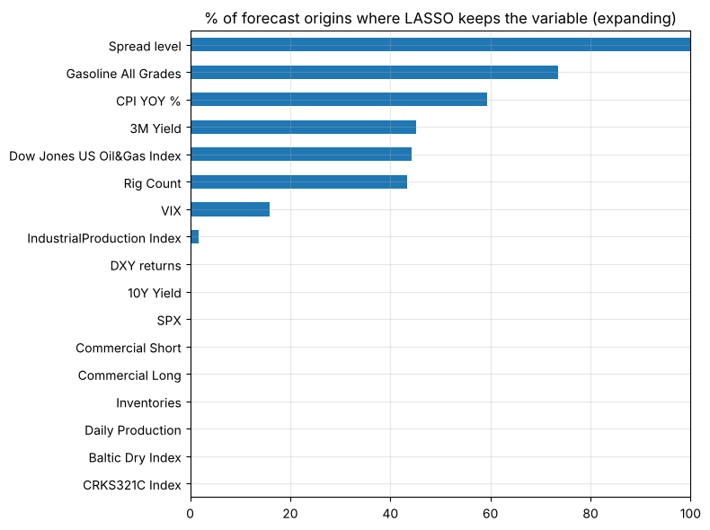
Table 8.2: sign and size when kept. Coefficients are on standardised predictors, so they are per one-standard-deviation move and comparable across rows. They are tiny because the target is a fraction (0.02 = 2%).
Predictor | Average coefficient | Share of times positive | Our reading | Confidence
Spread level | −0.0036 | 0% | Mean reversion. A wide spread invites arbitrage (buy storage, sell forward) and closes; backwardation resolves as supply responds | High
Gasoline | −0.0007 | 0% | Rising gasoline signals strong prompt demand, which lifts the front contract relative to the second, so the spread falls | Medium; fades after 2019 in the rolling betas
CPI (change) | −0.0004 | 0% | Inflation tends to accompany strong near-term demand; the effect is small and drops out when 2020 is removed (59% to 18%) | Low
3-month yield (change) | −0.0019 | 0% | Cost-of-carry theory predicts higher rates widen contango (a positive sign), the opposite of what we see. It appears only when 2020 is in training, so treat it as a 2020–2023 regime artefact | Low
Oil & gas index | −0.0023 | 0% | Equity strength in 2021–22 coincided with tight oil markets and backwardation: coincident, not causal. Only with 2020 in training | Low
Rig count | +0.0008 | 100% | The sign is not intuitive (more rigs means more future supply, which would narrow the spread). Only with 2020 in training; do not interpret | Low
VIX (change) | +0.0001 | 94% | Tiny; no economic claim | Low
Industrial production | +0.0002 | 100% | Kept in 2% of origins; ignore | Low
The unselected predictors (inventories, production, positioning, shipping, dollar, 10-year yield, S&P 500, crack spread) add no information about next month's spread change once spread level and gasoline are known. That is not proof they are irrelevant, and the production series is stepped and the inventory data may be noisy. The readings above are plausible stories consistent with the signs, not tested causal claims.
Figure 8.3: LASSO coefficients over time and the number of predictors kept (expanding window, top six). Before March 2020 the picture is simple and stable: two or three predictors, with spread level near −0.002 and gasoline near −0.001. In March to May 2020 the spread coefficient jumps to about −0.0058, the 3-month yield, oil and gas index and rig count enter, and the count rises to 6 or 7. The new coefficients then barely move through 2024, because an expanding window never drops the 2020 rows. The model's structure changed abruptly in spring 2020 and never changed back, which is consistent with the Chow tests, supports testing a rolling window, and matches the finding that the extra predictors only appear when 2020 is in training.
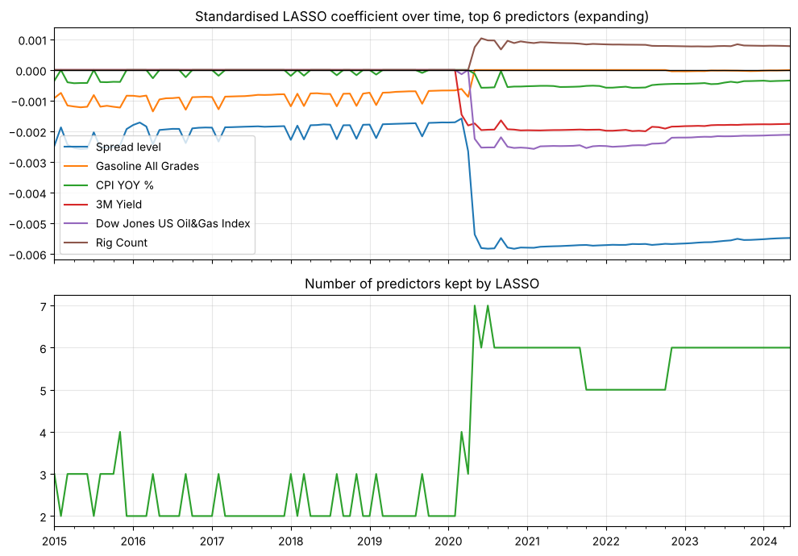
Table 8.4: do the two windows agree? Share of origins where each predictor is kept.
Predictor | Expanding | Rolling
Spread level | 100% | 52%
Gasoline | 73% | 39%
CPI | 59% | 29%
3-month yield | 45% | 34%
Oil & gas index | 44% | 28%
Rig count | 43% | 22%
VIX | 16% | 36%
Commercial short | 0% | 35%
Inventories | 0% | 31%
Dollar index | 0% | 27%
10-year yield | 0% | 24%
Daily production | 0% | 23%
Baltic Dry | 0% | 22%
Crack spread | 0% | 16%
The two windows agree that spread level and gasoline matter most. Rolling selection is noisier: it keeps variables the expanding window never does, keeps no predictors at all at 45 of 113 origins (including the last), and keeps the spread level in only 52% of origins. With 120 months the selection is less repeatable, which is another reason to prefer expanding as the main case.
For the report (predictor assessment): LASSO keeps the spread level at every origin with a negative sign, consistent with mean reversion bounded by storage and financing costs, and gasoline most of the time. The other variables enter only once 2020 is in the training data, so we do not rely on them.

9. Diagnostics
Every test flags a problem except the overlap check (VIF): the forecasts leave a small pattern, error variance changes over time, and the relationship breaks at 2005, 2015 and 2020.
What is tested (DECIDED). LASSO has no standard errors, so the residual tests run on a post-LASSO OLS: the predictors LASSO keeps at the final forecast origin, refitted by OLS on the rows LASSO was trained on at that origin. This tests the model as it ends up. Ljung-Box and ARCH-LM also run on LASSO's actual out-of-sample errors. It is done for the expanding window (full sample) and the rolling window (latest 120 months). The Chow test runs on the expanding version only for now (OPEN, to discuss with the team). Stationarity is in section 4.
Table 9.1: the model being tested (expanding, fitted on 351 months, Feb 1995 to Apr 2024). Coefficients are in the original units of each predictor, so they are not comparable in size across rows.
Predictor | OLS coefficient
Spread level | −0.306
Oil & gas index | −0.047
3-month yield | −0.0143
Gasoline | −0.0131
CPI | −0.0054
Rig count | +0.0341
Table 9.2: in-sample fit and adjusted R² (Lecture 2). Adjusted R² penalises R² for the number of predictors.
Model | Predictors | R² | Adjusted R²
Post-LASSO OLS | 6 | 0.242 | 0.228
OLS on all 17 | 17 | 0.261 | 0.223
The all-variable model has the higher raw R² but the lower adjusted R², a small in-sample argument for LASSO's pruning. Cautions: this is in-sample and measured against the sample mean, so it is not comparable with the 9% out-of-sample R², which is measured against the random walk. The predictors were chosen on the same data, so even the adjusted figure is optimistic. The lecture itself calls adjusted R² a "soft" rule with no distribution, so use it as context, not as a test.
Table 9.3: all diagnostic tests (flag = p below 0.05).
Area | Test | Run on | Window | p-value | Result | What it means
Autocorrelation | Breusch-Godfrey (12 lags) | Post-LASSO OLS residuals | Expanding | 0.026 | flag | The model misses some dynamics; OLS standard errors cannot be trusted as they stand
Autocorrelation | Ljung-Box (12 lags) | LASSO out-of-sample errors | Expanding | 0.028 | flag | The forecasts leave a predictable pattern behind
Autocorrelation | Ljung-Box (12 lags) | LASSO out-of-sample errors | Rolling | 0.025 | flag | Same
Heteroskedasticity | Breusch-Pagan | Post-LASSO OLS residuals | Expanding | below 0.0001 | flag | Error size depends on the predictors
Heteroskedasticity | ARCH-LM (6 lags) | Post-LASSO OLS residuals | Expanding | 0.021 | flag | Large errors follow large errors (volatility clustering)
Heteroskedasticity | ARCH-LM (6 lags) | LASSO out-of-sample errors | Expanding | 0.005 | flag | Same, on forecast errors
Heteroskedasticity | ARCH-LM (6 lags) | LASSO out-of-sample errors | Rolling | 0.010 | flag | Same
Parameter stability | Chow, break Jan 2005 (119 + 232 months) | Post-LASSO OLS | Expanding | 0.0004 | flag | Coefficients differ before and after 2005
Parameter stability | Chow, break Jan 2015 (239 + 112 months) | Post-LASSO OLS | Expanding | below 0.0001 | flag | Coefficients differ before and after 2015
Overlap | VIF (largest 1.33, limit about 10) | Post-LASSO OLS | Expanding | n/a | ok | No multicollinearity among the six kept predictors
Not run for the rolling window: the residual tests and VIF, because the rolling LASSO keeps no predictors at the final origin (it keeps none at 45 of the 113 origins), so there is no regression to test.
Reading them.
- Autocorrelation is only just significant (p about 0.03), so the pattern left in the errors is modest. Standard fix: Newey-West (HAC) standard errors for inference. The out-of-sample forecast comparison does not use OLS standard errors, so it still stands.
- Heteroskedasticity is strong for Breusch-Pagan. Volatility clustering matters to a trader: the risk of a spread position is not constant, and 2008 and 2020 dominate. Standard fix: robust (HAC) standard errors.
- Stability. Both Chow tests reject. The 2005 date was spotted in the descriptive statistics, so it is data-informed (say so); 2015 is our own train and test split. Standard fix: a rolling window or a break dummy.
- Caveat on every p-value. The predictors were chosen using the same data, so the p-values are somewhat optimistic. The Chow date for 2020 was not tested formally; the rolling betas below and Figure 8.3 are the evidence for it.
Figure 9.4: rolling betas. The post-LASSO regression refitted on a sliding 120-month window (standardised predictors, 95% Newey-West bands, March to May 2020 shaded). It uses the expanding model's six predictors, because the rolling LASSO is empty at the end. Spread level is stable at about −0.006 before 2020 and deepens to about −0.01 afterwards; its band excludes zero in 99.6% of windows. The 3-month yield and the oil and gas index sit near zero for most of the sample and turn clearly negative after 2020, and the rig count turns positive. Gasoline is negative from 2009 to 2019, then about zero. CPI is mostly negative but significant in only 47% of windows. The sudden steps in 2008–09, 2018–19 and 2020 look like single extreme months entering or leaving the window (the 2008 crash dropping out around late 2018), not slow drift. So the spread's mean reversion is the stable core and everything else is regime-dependent. This is a descriptive chart, not a lecture method or a formal test; consecutive windows share 119 of 120 months, so the lines are smooth by construction.
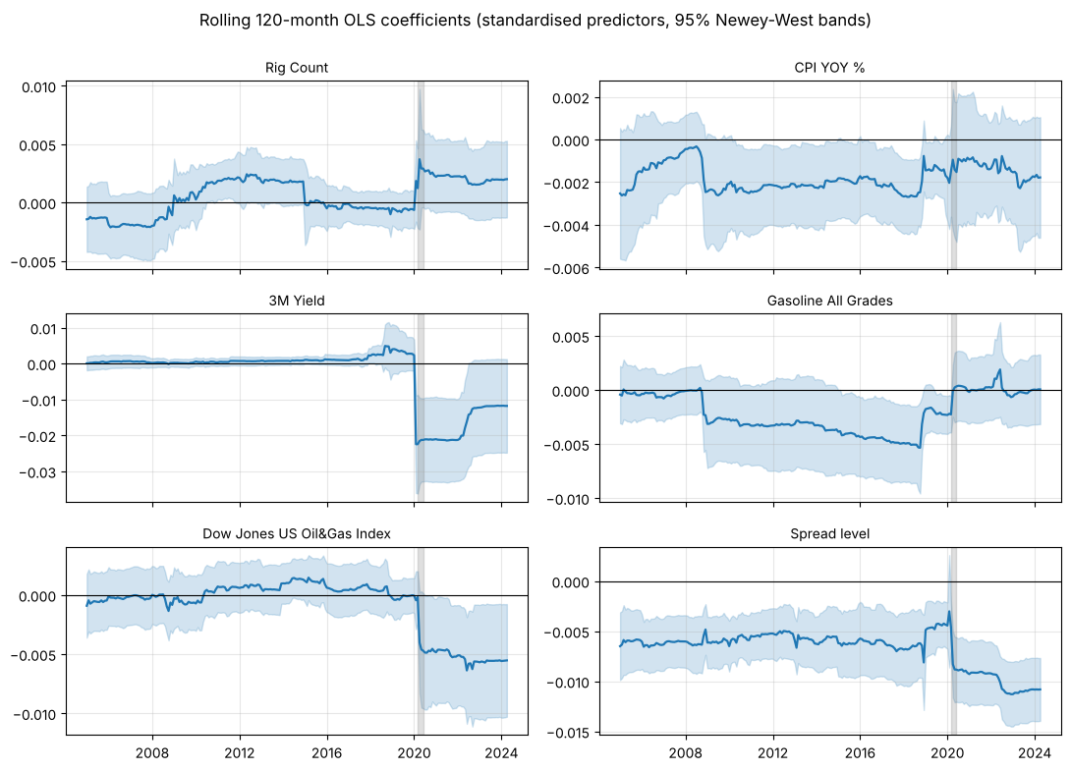
For the report (diagnostics): the diagnostics flag autocorrelation, changing error variance and parameter instability, so we treat inference on individual coefficients with caution and rely on the out-of-sample comparison. The only stable relationship is the mean reversion of the spread.

10. Trading rule and results
Trading the sign of the LASSO forecast made $16.05 per barrel of spread over the test period, but three years (2015, 2020, 2021) account for $14.88 of it, so the evidence is suggestive, not strong.
The rule (PROPOSED). If the forecast change is positive, buy CL2 and sell CL1 (long the spread, position +1); if negative, sell CL2 and buy CL1 (short the spread, position −1). Profit each month = position × the actual next-month change in the dollar spread (CL2 − CL1), in dollars per barrel. It is always in the market, one unit, with zero costs. The threshold (only trade if the forecast is large enough), position size and costs are still to be decided (OPEN), as is which benchmark lines go in the report: a flat line at zero (a random walk never trades) and an "always long the spread" line (the more informative comparison). The professor suggested a line chart of the strategy against the benchmark (DECIDED).
Table 10.1: profit per barrel of spread (expanding window, costs = 0).
Strategy | Total P&L, all 113 months | Sharpe | Months profitable | Worst drawdown | Total P&L without Mar–May 2020 (110) | Sharpe without
LASSO | $16.05 | 0.74 | 57.5% | −$3.11 | $8.52 | 0.52
OLS (all 17) | $9.33 | 0.42 | 57.5% | −$3.85 | $9.50 | 0.59
Always long the spread | −$1.65 | −0.07 | 45.1% | −$6.79 | −$1.82 | −0.11
No trade (random walk) | $0 | n/a | n/a | $0 | $0 | n/a
Sharpe is the average monthly profit divided by its standard deviation, scaled to a year (times the square root of 12). Drawdown is the biggest fall from a previous peak of cumulative profit. The "without" columns only drop those months from the profit calculation; unlike section 7 they do not re-run the model.
What it says.
- Always long loses money, so the profit is not just from owning the spread; the forecast adds something.
- Concentration. LASSO's profit by year: 2015 +$3.70, 2016–2019 +$1.04 in total, 2020 +$8.08, 2021 +$3.10, 2022 +$0.12, 2023 +$1.30, 2024 (to June) −$1.29. March to May 2020 alone is +$7.53: the sign was right in all three months (+$3.85, +$1.02, +$2.66) even though the forecast sizes were tiny. Without them: $8.52.
- Profit and R² are different measures. Without the COVID months OLS slightly out-earns LASSO ($9.50 vs $8.52) despite its worse R². The rule uses only the direction of the forecast, while R² weighs the size of the miss. LASSO's hit rate is 60.2% but 57.5% of months are profitable, because the large months count for more.
- Likely a mean-reversion trade. The spread level is the one predictor kept at every origin, so the rule is probably close to "sell the spread when it is high, buy it when it is low". We have not tested that directly (see open items).
Figure 10.2: cumulative profit, $ per barrel of spread (expanding window). LASSO (thick blue) rises slowly to about $5 by the end of 2019, jumps by about $8 in March to May 2020, rises again by about $5 around the turn of 2021–22, and has been flat to slightly down since. OLS follows the same shape at a lower level. Always long (green) drifts below zero. The grey band is March to May 2020. The chart is dated by forecast origin, one month before the month being forecast, so the 2020 jump starts a month earlier than in the yearly figures above, which are by target month. The drawdown never exceeds $3.11, and profit with zero costs is an upper bound: a rule that can flip every month would pay costs every month.
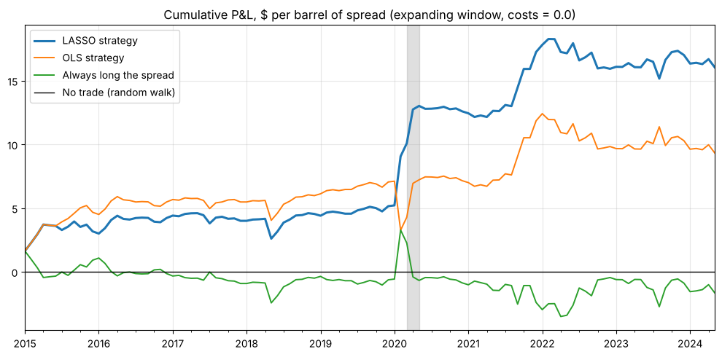
For the report (trading): a simple calendar-spread rule that follows the sign of the forecast earned $16.05 per barrel over 2015–2024 against a loss for always being long, but about half of it came in March to May 2020 and transaction costs, contract rolls and liquidity are ignored, so it is an illustration, not a strategy.

11. Limitations and honest caveats
The evidence for forecasting ability is modest, concentrated in one shock, and the model's structure changes over time; the report should say so plainly, since the brief grades honesty and interpretation, not beating the market.
- Weak and concentrated evidence. Out-of-sample R² is 9.0%; 94% of LASSO's cumulative squared-error gain over the random walk comes from three months; there is no formal significance test (Diebold-Mariano was dropped as it is not in the lectures); the 60.2% hit rate is about two standard errors above a coin flip. The lectures themselves note that most forecast models do not beat a naive forecast by much.
- A changing relationship. The average spread flips from backwardation to contango across decades, both Chow tests reject, and LASSO's structure jumps in spring 2020 and never reverts. Only the mean reversion of the spread is stable.
- 2020 distortion. March to May 2020 are 90% of the random walk's squared error. We report results with and without them, and we do not delete them from the headline.
- Trading simplifications. Zero transaction costs, always in the market, one unit, no threshold, unconstrained size and no liquidity limits. A rule that can flip every month would pay costs every month.
- Contract rolls. Monthly CL1 and CL2 are the front two contracts at each month-end. When the front contract expires between two month-ends, "CL1" becomes a different contract, so the measured spread change includes a roll effect that a real position would not earn exactly.
- Data timing. The extra month of lag for CPI and industrial production is unverified, and industrial production is probably final-vintage (revised) data, so a trader in real time would have seen something noisier.
- Selection and inference. Predictors were chosen on the same data the diagnostics use, so p-values are somewhat optimistic. The residual tests run on a post-LASSO OLS, not on LASSO itself. The rolling LASSO keeps no predictors at the final origin, so its residual tests could not be run.
- Scope. One-month horizon only; monthly data (slower reaction, fewer observations); only the front two contracts, so we see the slope of the curve but not its full shape; Brent was removed after the professor flagged a data issue.
- Many variants, few fixed in advance. We ran two windows, two models and several COVID variants. The window rule (lowest RMSE) and the COVID windows should be fixed in the log before results are quoted, so the headline is not chosen by what looks best.
For the report (limitations): the results are an honest first test, not a trading system: the gain over the random walk is modest and concentrated in March to May 2020, the relationship shifts across regimes, and costs, rolls and liquidity are ignored.

12. Differences from the teammates' draft, and what is still open
The draft report's outline matches the analysis closely, but ten statements need changing to match what the code and the decisions now say.
Draft section | The draft says | The code and decisions say
2, 3, 4 | 16 candidate predictors | 16 candidate series plus today's spread: 17 features, after Brent was removed
3 | A "small" OLS baseline, but also OLS on all 16 predictors performing poorly | The comparator is OLS on all 17 variables; the residual diagnostics use a post-LASSO OLS on the 6 predictors LASSO keeps at the final origin
3 | Penalty tuned within the 1995–2014 training window | Re-tuned at every forecast origin on that origin's window, which grows to 351 months (expanding) or stays at 120 (rolling)
4 | Chow test at pre- and post-2008 | Jan 2005 and Jan 2015 (decided); 2020 is shown by the rolling betas and the LASSO coefficient chart
4 | Breusch-Godfrey on in-sample OLS residuals | On the post-LASSO OLS residuals; Ljung-Box on LASSO's out-of-sample errors
4 | Diagnostics numbered 1 to 9 under five categories | Nine tests in five categories: renumber or drop the numbers
5 | COVID check by re-scoring | Re-run without those months in both training and scoring; the scoring-only version is the simpler baseline
5 | Metrics: RMSE, out-of-sample R², directional accuracy | Also MAE and MAPE (MAPE may be dropped); no Diebold-Mariano test
2 | Differencing "guarantees" the target is stationary | We tested it: target stationary; two series unclear (spread level, daily production)
2 | Shell removed to prevent multicollinearity | Company stocks removed because they repeat the oil and gas index and Shell is missing 127 months; Total Open Interest and Brent also removed; VIF among the kept predictors is at most 1.33
Things in the draft that already match: the target definition, the monthly sheets and 355 rows, the extra lag for CPI and industrial production, the 113-month test sample, the random-walk benchmark, standardisation, time-series cross-validation, and the trading rule.
Missing from the draft and covered here: the abstract and results numbers, the figures, the predictor assessment (section 8), an in-sample number for the in-sample versus out-of-sample point (Table 9.2), the conclusion and the appendix. The report is capped at 2,000 words, and the slide-citation bullets will use a lot of that.
Still open
- Final predictor list and transformations: confirm the 16 series, and the extra lag for CPI and industrial production.
- OLS comparator: keep OLS on all 17, or refit OLS on LASSO's selected predictors at each origin so the comparator, the diagnostics and the forecasts describe the same thing.
- Main window and the rule: the lowest-RMSE rule picks expanding, but the ranking flips without the 2020 shock (section 7).
- LASSO tuning: 5 folds and the lowest-error rule are placeholders. The rolling LASSO keeps nothing at the end of the sample, so trying the sparser "1 standard error" rule or fewer folds would be a sensible check.
- Rolling diagnostics: what to do when the rolling LASSO is empty at the final origin (error tests only, use the last non-empty origin, or drop the rolling diagnostics), and whether to run the Chow test on the rolling window.
- Trading: threshold, size and costs; which benchmark lines go in the chart; and a check of whether the rule is just "short the spread when it is high".
- MAPE: keep or drop.
- 2020 in the headline: keep it in (our recommendation) or add a 2020 dummy.
- Parked ideas: forecasts 2 and 3 months ahead; a full futures curve (needs data beyond CL1 and CL2, and the professor should say whether he means the futures curve or the interest-rate curve); a scatter of today's spread against next month's change, and curve snapshots at selected dates.

